“Get Your Fill!” Policy Template (public-facing)
*Please note that this template was reviewed by an AHS representative*
Bring Your Own & Get Your Fill!
(Business name) accepts clean reusable customer cups and containers. Here’s what you need to know to get your fill:
- Let us know that you want to “bring your own” container if you’re placing an order in-store, over the phone, or online.
- Make sure your cup and/or container is:
  - Visibly clean
  - Made of durable materials (ex. food grade, suitable for hot foods)
  - The right size for what you’re ordering
- If your cup or container is not clean or suitable for refill, we will kindly have to decline and ask you to follow the above steps for next time!
- Add anything else your business wants to stipulate here, where applicable. For example:
  - We can wash, rinse, and sanitize your cup if needed
  - If packing up your leftovers in your own container, we kindly ask that you do so at your table
  - Staff are required to wash hands after handling customer cups and containers (this may be appreciated by the public)
Thanks! By remembering to “bring your own”, you help Banff reduce single-use waste and protect the park for generations to come.
Visit Banff.ca/SingleUse for more information on the strategy and bylaw.
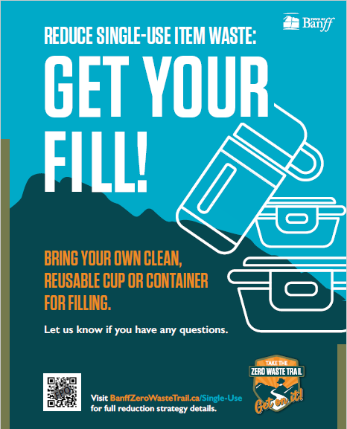
Health & Safety Checklist (for managers & staff)
According to public health guidelines, with sanitation procedures in place, commercial food establishments may accept:
- “Suitable and visibly clean customer provided containers” OR
- “Offer to clean and sanitize the item prior to use”, depending on the facility’s sanitation procedures.
Sample Checklist for Accepting Customer Reusable Cups & Containers
Considerations | Checklist
Dishwashing Infrastructure | - Our facility has either a commercial dishwasher or a three-compartment sink for washing, drying, and storing reusable dishes
Assessing Customer Cups & Containers | - Container is visibly clean  - Container is made of materials that are durable and easy to clean (i.e., food grade, suitable for hot foods, etc.)
Procedure for Refill | - Ensure reusable item is visibly clean  - Staff may rinse cups with hot water prior to filling  - Ensure reusable dishes do not cross-contaminate food or food contact surfaces; which may include:  - no-touch dispensing  - not touching the container with serving utensils  - washing spoons used for stirring beverages in customer’s cups between every use  - Ensure the customer container is returned only for the same customer that provided the container
Sanitizing Procedures after Refill | - Sanitizing food contact surfaces (utensils, dispensers, counters) after  - Staff must wash hands after refill

