New Requirement: Food & Recycling Ban
The Town of Banff has recently passed a bylaw that requires all non-residential sector entities to separate food scraps and recycling from garbage. The bylaw will come into effect on October 1, 2022 with enforcement beginning in 2023.
All businesses at (name of building) are expected to participate in the program. If our garbage bin contains visible amounts (no more than 10%) of food scraps and recycling will no longer be acceptable and could be subject to fines.
Food Scraps | Recycling
All buildings in Banff are required to provide bins for diversion of food scraps, garbage and cardboard. These bins are collected by the Town of Banff Resource Recovery. | Recycling may be disposed of free of charge at the Waste Transfer Site or in any Blue Bin around town. You may also choose to hire a private hauler.
Food Scraps includes the following:  - Fruits & vegetables  - Pits, peelings, rinds, tops, cores and husks  - Rice, breads, cereal, noodles, toast, tortillas, baked goods, pastries, pies, etc.  - Pumpkins  - Coffee grounds and filters  - Tea bags and leaves  - Dairy products  - Paper soiled with food  - Egg & eggshells  - Popsicle and stir sticks (wooden only)  - Meat, fish & bones  - Paper towels | Recyclable materials include:  - Paper: paper and newsprint  - Plastic & Metal: food cans & foil, plastic containers & bottles  - Glass: non-refundable glass jars  *A separate bin must be provided for commercial cardboard as it is not permitted in blue bins

Banff is Moving Toward Zero Waste
Diverting food scraps & recycling from landfill supports the Town of Banff’s goals to reach 70% waste diversion by 2028, zero waste to landfill, and ultimately become a model environmental community.
Need assistance?
The Town of Banff provides all businesses with zero waste assistance including program set-up advice and staff engagement tips. Businesses that are new to waste diversion and begin separating before the bylaw comes into effect will be provided with a free starter kit including a decal kit and compostable bags.
Additional How-To information is available at BanffZeroWasteTrail.ca/Commercial.
Thank you for joining us in helping Banff move toward zero waste and become a model environmental community. If you have any questions, please contact (property manager/owner contact name, number, email)
Sincerely,

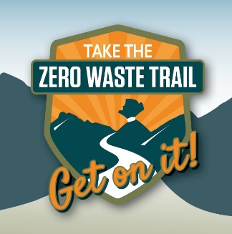
Need assistance, or want to learn more about moving toward zero waste? Sign up for a waste assessment by emailing zero.waste@banff.ca

